- Install python packages required to run the application. Copy and paste the below command to the terminal.
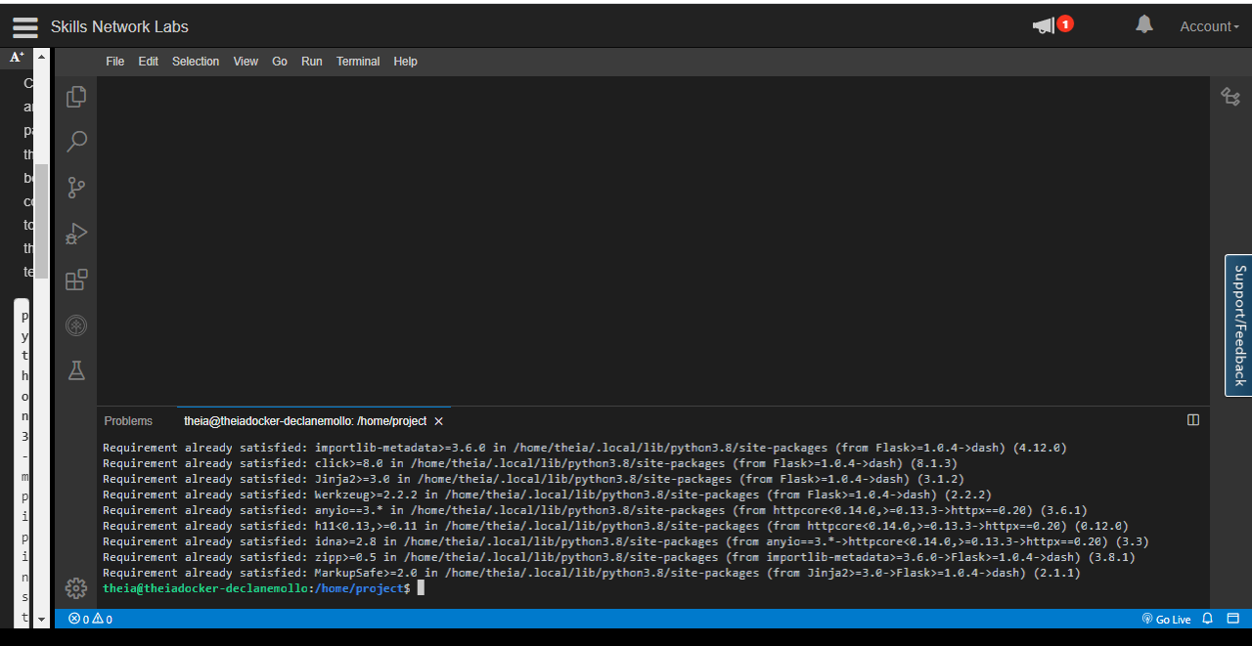

- Open a new terminal, by clicking on the menu bar and selecting Terminal->New Terminal, as in the image below.
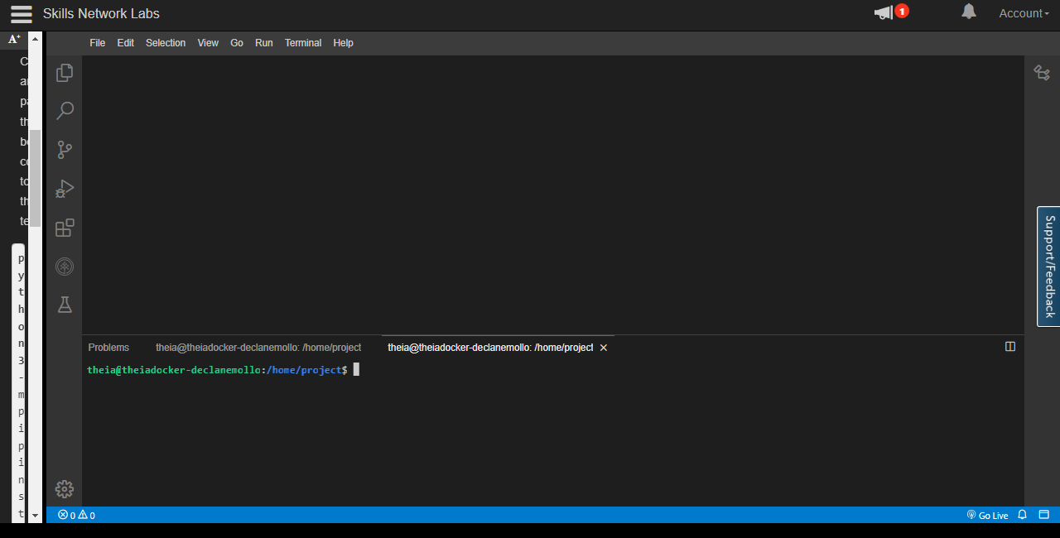

TASK 1 - Dash Application layout
Let's start with
- Importing necessary libraries
- Title added using html.H1() tag
- Create a new python script, by clicking on the menu bar and selecting File->New File, as in the image below.
- Provide the file name as dash_layout.py

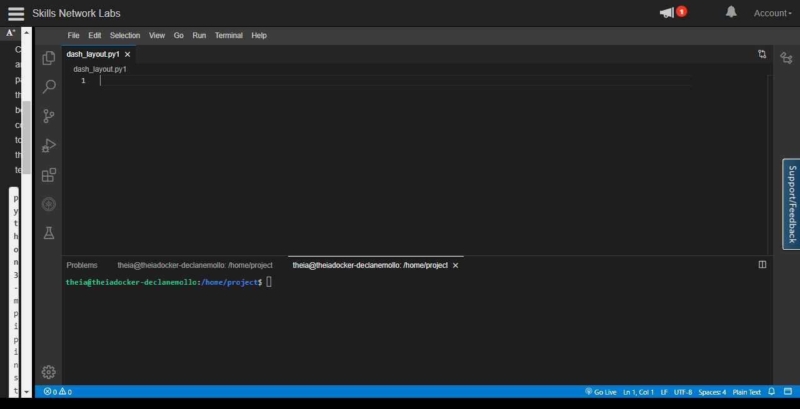

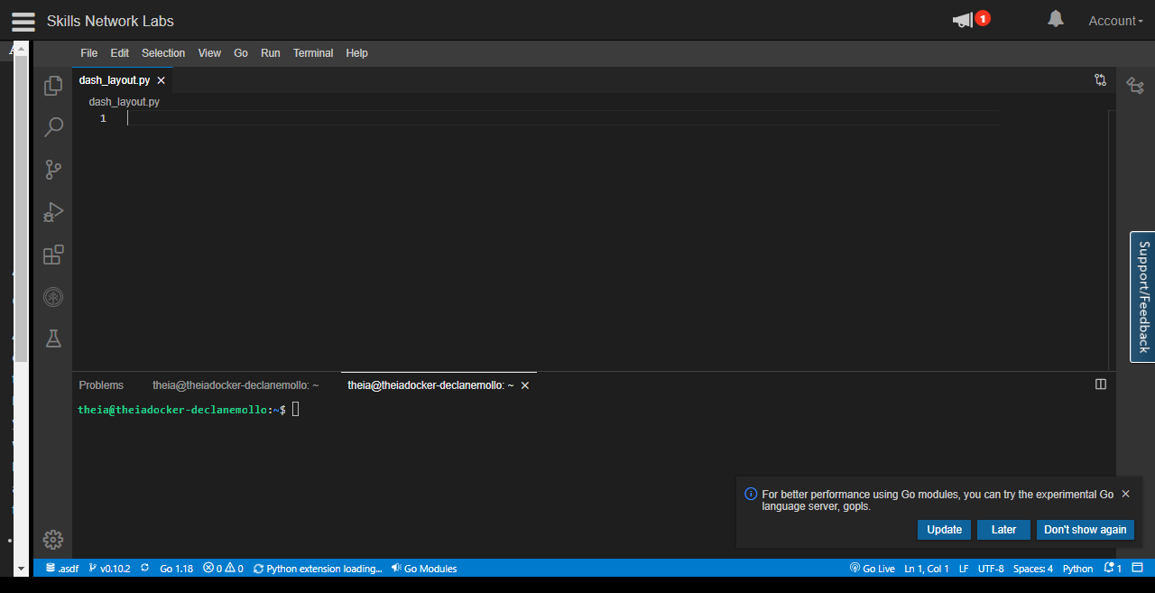

- Copy the below code to the dash_layout.py script and review the code.
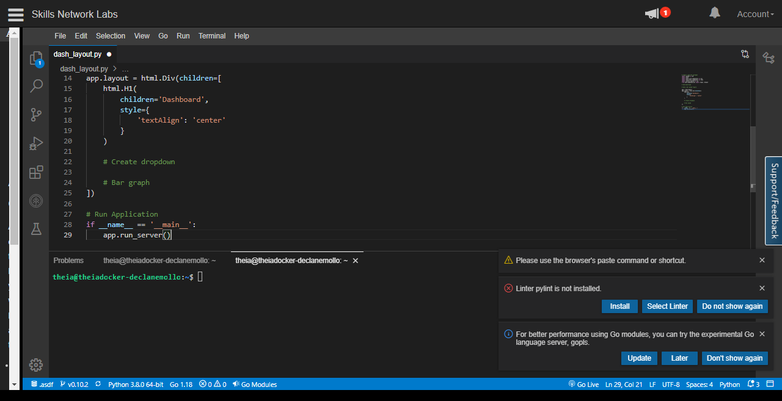
- Save the application using Save option from File menu.

- Run the python file using the following command in the terminal

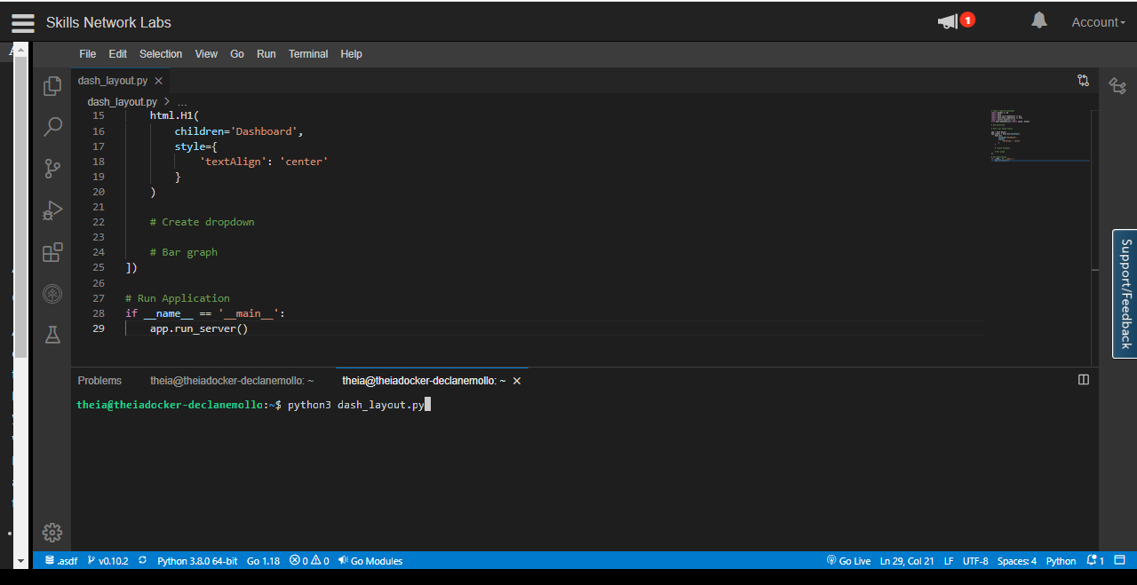
- Observe the port number shown in the terminal.

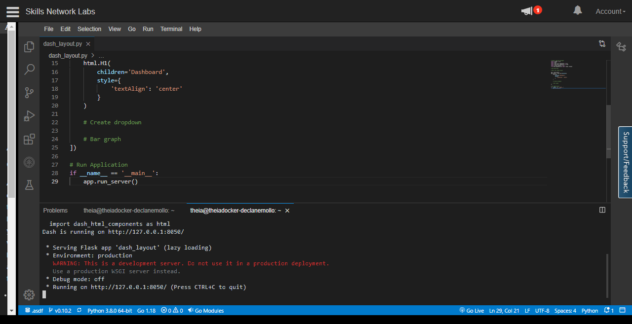
- Click on the Launch Application option from the side menu bar. Provide the port number and click OK
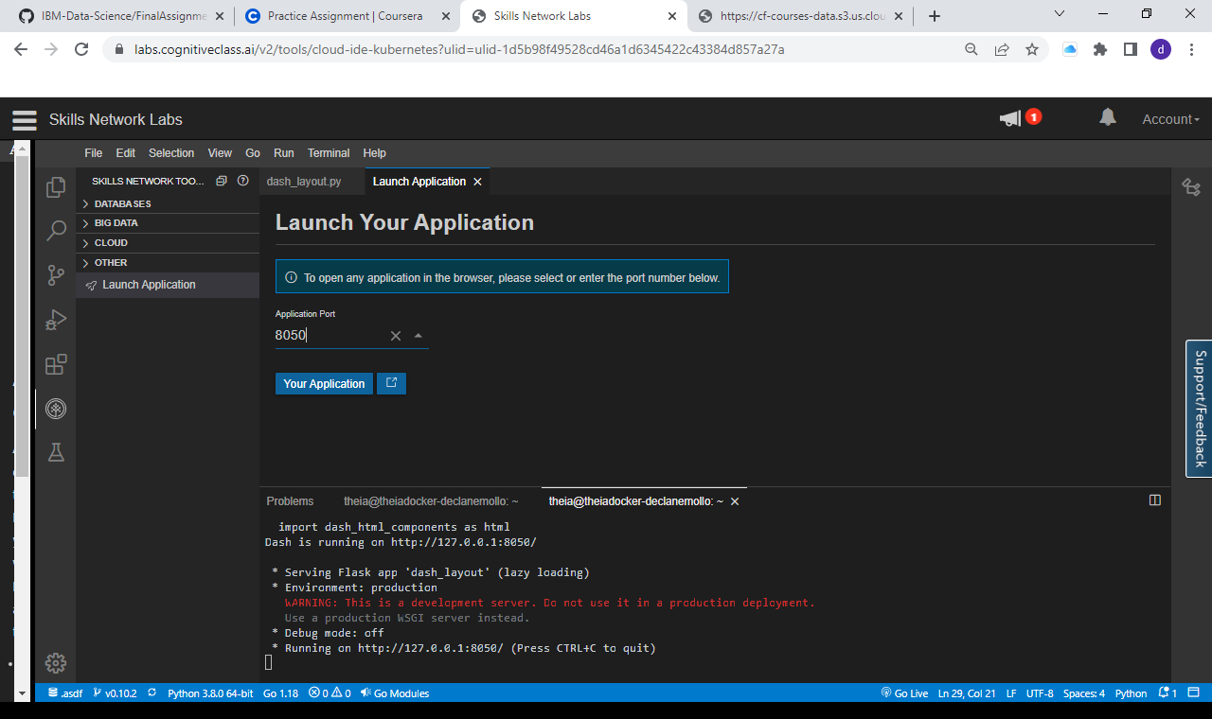

- The app will open in a new browser tab like below:

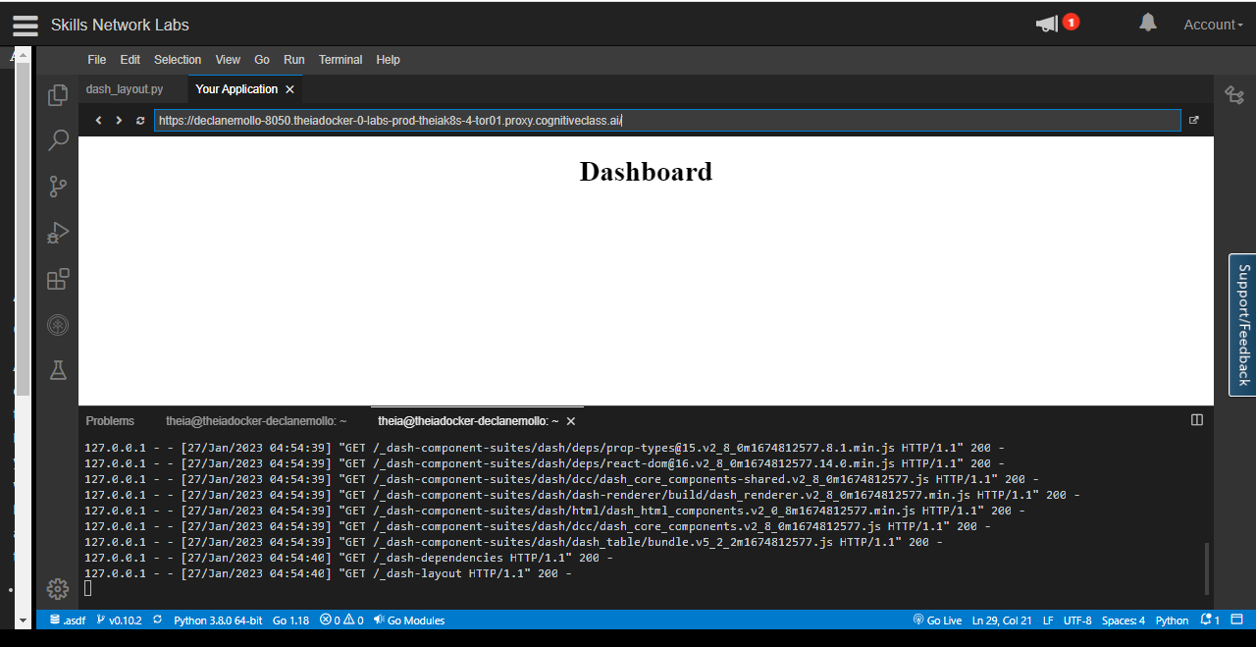

Add dropdown
- You can generate a drop down as shown below. You do by calling Dropdown off dash_core_components and passing the options as a list of dictionaries. You can set the default value using the value attribute and passing in the default option.
Note:
- Add a comma (,) before the placeholder in the skeleton file and then place the code.
- The placeholder here is "# Create dropdown " in the skeleton file.
- Add small letter "u" just before the city name "MontrÃ©al" like this u'MontrÃ©al' as it contains special characters.

# Create dropdown
dcc.Dropdown(options=[
{'label': 'New York City', 'value': 'NYC'},
{'label': 'Montréal', 'value': 'MTL'},
{'label': 'San Francisco', 'value': 'SF'}
],
value='NYC' # Providing a vallue to dropdown
)

- After adding the dropdown the dashboard is displayed as below.

